LAB # 04

Exercise

Theory Question
- What is hyperlink and write their types?
Answer:
A hyperlink is a clickable element (text, image, or button) in an HTML document that connects one web page to another page, file, or location.
Syntax:
<a href="url">Link Text</a>
HTML Hyperlink Types.
Links are used to “link” a visitor from one area to another.
There are three types of links:
1. Local or Relative: A page on the same server or directory
2. Internal: A section on the current page or document
3. External or Absolute: A page or site on a different server or directory

2) Describe Target attribute of HTML hyperlink.
Answer:
The target attribute specifies where the linked document will open when the hyperlink is clicked.
Syntax:
<a href="url" target="_value">Link</a>

Values of Target Attribute:
The target attribute can have one of the following values:
_self - Default. Opens the document in the same window/tab as it was clicked
_blank - Opens the document in a new window or tab
_parent - Opens the document in the parent frame
_top - Opens the document in the full body of the window
Example:
<a href="https://google.com" target="_blank">Open Google in New Tab</a>

3) Hyperlink how will appear as follows in all browsers?
Answer:
By default, a hyperlink appears as follows in all browsers:
- Unvisited Link → Blue color with underline
- Visited Link → Purple color with underline
- Active Link (being clicked) → Red color with underline
- Mouse Hover → Hand (pointer) cursor appears
Example:
<a href="https://google.com">Visit Google</a>
This link will appear blue and underlined in all browsers until visited.

Practical Question
- Write a HTML program on your web site project same as Example-3 of chapter-3.

Input
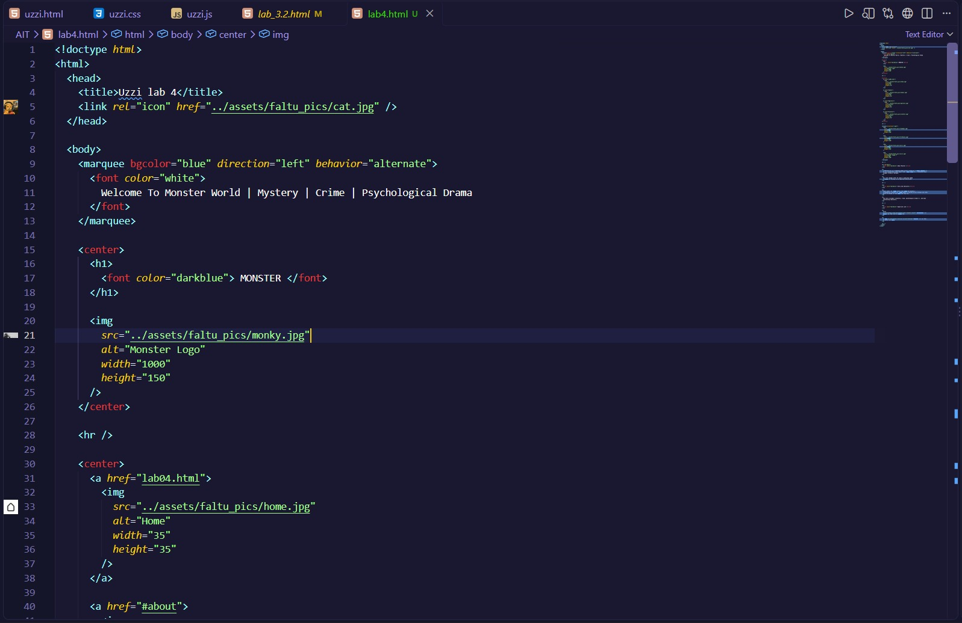

Output
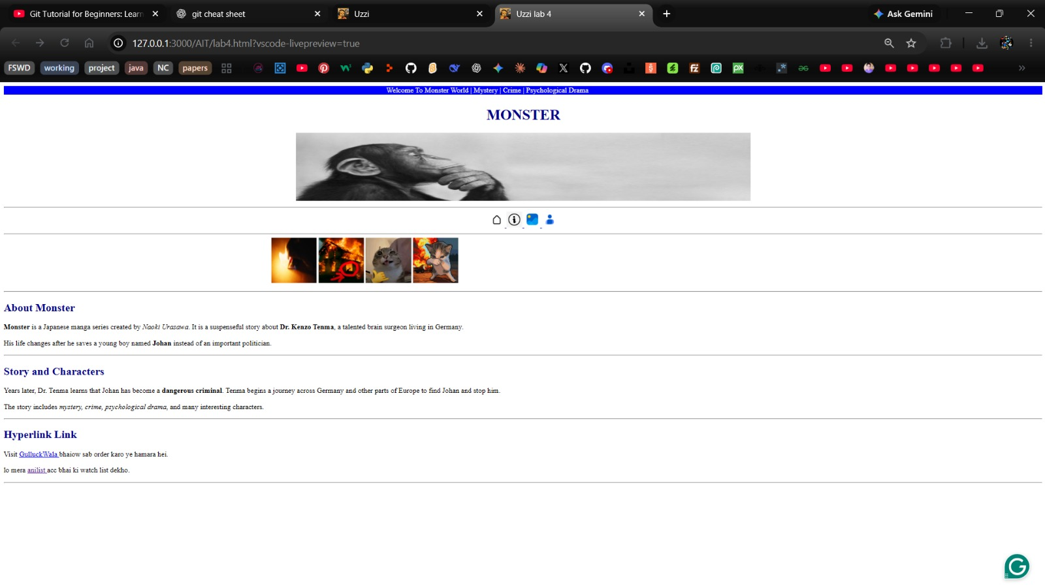

Objective and MCQ
- Which target value to Opens the document in a new window or tab
  - _blank
  - _new
  - _self
  - _top

- Which an unvisited link is underlined and ____ color.
  - red
  - green
  - blue
  - purple

- The HTML______ tag defines a hyperlink.
  - <a>
  - <href>
  - <src>
  - <link>

- Which syntax of hyper link is best way.
  - <a href=abc >
  - <hef a="index.html"> Click Here </a>
  - <a href="index.html"> </a>
  - <a href="index.html"> Click Here </a>

- Which a visited link is underlined and ____ color.
  - red
  - green
  - blue
  - purple

